8.4-8.5 Vocabulary
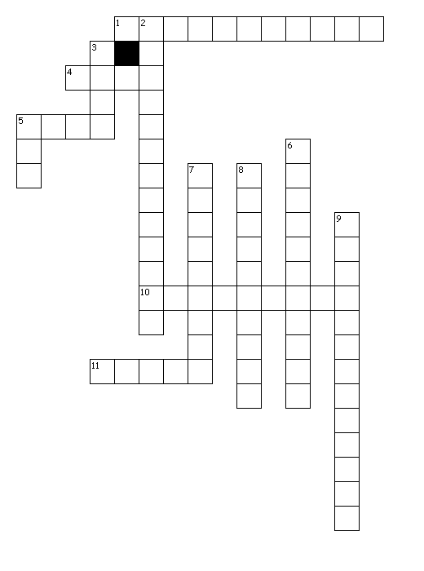
Across
1. Process that converts an mRNA message into a polypeptide (protein)
4. An intermediate message that is translated to form a protein
5. Forms part of ribosome
10.Signals the end of amino acid chain
11.3 nucleotide sequence that codes for an amino acid
Down
2. Enzyme that bonds nucleotides together in a chain to make a new RNA molecule
3. Brings amino acids from the cytoplasm to the ribosome to help make a growing protein
5. Temporary copy of DNA that is used to make a protein then destroyed
6. Information flows from DNA to RNA to Proteins
7. Set of 3 nucleotides that are complimentary to mRNA codon
8. Methionine, signals the start of translation
9. The process of copying a sequence of DNA to produce a complimentary strand of RNA

